 | World Sustainability Fund  WSF advice to The Bureau of UNFF 10:
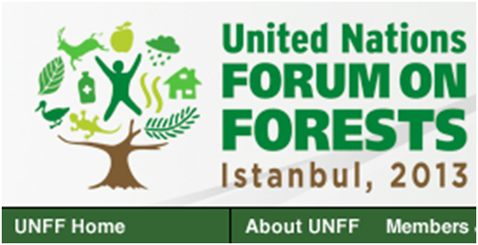

Up front of Your Istanbul Conference of April 8-19 we like to honor You with our Meta Calculations for the restoration of 150 mio ha degraded land (global level):

- At an average project size of 10.000 ha, 15.000 projects are needed. With 200 countries this means 75 projects per country;

- Overal 150 million ha - indicative numbers:
- Investment $ 750 billion;
- Net CO2 sequentering 100 till 150 million tonne;
- Revenue Break Even Point over 20 years at 8% net result;
- At 21% net result $ 2.185 billion revenue, exclusive growth of land value;
- Yearly up to 420 billion liters of crude biomass oil production at BEP;
- At 2,5% $ 187 billion interest income for loan institutes;
- Positive results on global CO2, climate, resources, labor, floods, landslides and droughts;

See: http://www.un.org/esa/forests/session.html and
http://webtv.un.org/watch/plenary-un-forum-on-forests-10th-session/2290241082001/

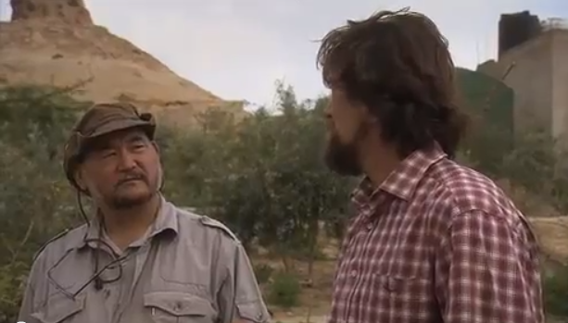

Met John Liu werkt onze Reinier Bosman aan herbebossing van gedegradeerd land in Rwanda en potentieel andere landen, zie ook http://www.youtube.com/watch?v=YBLZmwlPa8A en http://www.whatifwechange.org/index.php#/allStories.

